  REPORT TO | ON
CABINET | 6 December 2017
September 2017
TITLE | PORTFOLIO | REPORT OF
Samlesbury Play Area | Regeneration & Leisure  Corporate Support & Assets | Director of Development, Enterprise and Communities

Is this report a KEY DECISION (i.e. more than £100,000 or impacting on more than 2 Borough wards?)  Is this report on the Statutory Cabinet Forward Plan?  Is the request outside the policy and budgetary framework and therefore subject to confirmation at full Council?  Is this report confidential? | No  Yes  No  No

- PURPOSE OF THE REPORT

Members are asked to consider the transfer of land on a long term lease to Samlesbury Parish Council, for the purposes of creating a village play area. Subject to external resources being secured by the Parish Council to fund and install play equipment, Members are asked to approve a contribution of £10,000 from South Ribble Borough Council.

- PORTFOLIO RECOMMENDATIONS
Recommends subject to external funding being secured by Samlesbury Parish Council, to agree transfer of SRBC land at Nabs Head Lane to Samlesbury Parish Council, by way of a 25 year lease including a ten year break clause.

Recommends match funding contribution of £11,200 from SRBC, comprising of £1,200 revenue funds for statutory notices and £10,000 capital monies, subject to approval by the Eastern My Neighbourhood forum.

3. CORPORATE PRIORITIES

The report relates to the following corporate priorities:

Clean, green and safe | ✓ | Strong and healthy communities | ✓
Strong South Ribble in the heart of prosperous Lancashire |  | Efficient, effective and exceptional council

- BACKGROUND TO THE REPORT

4.1 There has been a longstanding community demand for a play area at Samlesbury. This is been on the Eastern My Neighbourhood plan for over a year and there have been several requests from the community prior to this. A council owned and maintained piece of land in Samlesbury with 2 goalposts is currently the only play amenity in the parish. The area is checked on a weekly basis and mown by SRBC as part of a regular maintenance regime. Whilst demand may be low compared to other play areas within the borough, a play facility at this location would be the only facility within reasonable distance of Samlesbury. The nearest facility within South Ribble is at Higher Walton which is over 5 kilometres away. Whilst SRBC may not be able to maintain a play facility, the Parish Council will take on responsibility to provide and maintain a facility for families. Checks into funding options have included accessing Cuadrilla’s community fund, but the project is ineligible. The parish council will continue to look at external funding options for as long as possible to maximise any opportunities that may arise.

4.2 The local Parish Council has been working with ward members and local community and business groups to develop a play area proposal for the land in Samlesbury. They wish to install a high quality play area with equipment and soft surface landscaping, suitable for a children of all ages.

5. PROPOSALS (e.g.RATIONALE, DETAIL, FINANCIAL, PROCUREMENT)

5.1 Samlesbury Parish Council, wishes to create a play area on SRBC land for the benefit of the local community. This proposal is to allow the Parish Council and their partners to build a play area and manage the land.

5.2 Subject to recommendations being approved, SRBC would remain the land owner, but the Parish would be responsible for resourcing and building the play area by leasing the land from SRBC on a peppercorn rent. A 25 year lease is proposed to provide security of tenure for the Parish Council, and to assure external funders of the joint commitment of Samlesbury Parish Council and SRBC on this project. It is also proposed to have a ten year break clause to allow review and give both parties options.. SRBC remains the owner and would still hold rights for future options.

5.3 Maintenance of the play area would be the responsibility of the Parish Council. This means there would be no increase in revenue costs to SRBC as a consequence of the site development. Value is added with the provision of enhanced local amenities at no ongoing revenue cost to SRBC. The Parish Council is working with one of the Directors of Playdale, a playground equipment company (used by SRBC), to develop plans of the site. The Playdale Director lives within the Parish and is keen to deliver a high quality play facility locally. The Parish is also in communication with businesses, including British Aerospace, to look at funding the proposals.

5.4 The total cost estimate for these works is currently £90,000. It is intended that these costs would be met by the Parish Council and their partners. Maintenance and insurance of the equipment and surfaces would also be covered by the Parish Council.

5.5 Should this proposal be approved, the Parish Council will begin fundraising immediately. Subject to Cabinet approval, Members may wish to support the Parish by offering to match £80,000 raised by Samlesbury Parish with a final £10,000 contribution to make the total £90,000 needed. The possible SRBC contribution could be funded from £5,000 Eastern My Neighbourhood Forum core funds and £5,000 from S106 contributions.

5.6 Cabinet permission is sought to allow a final (lease) agreement to be made based on the principles described. This would be undertaken, with Cabinet permission, by Director of Neighbourhoods, Environmental Health and Assets in consultation with Deputy Leader/Corporate Support and Assets.

5.7 In addition, Cabinet approval is sought to make a £10,000 capital contribution from SRBC to the project, once officers are satisfied the Parish has raised the necessary funding to be able to commit to the project.

6. CONSULTATION CARRIED OUT AND OUTCOME OF CONSULTATION

6.1 Consultation has been carried out by both SRBC and Samlesbury Parish Council in Spring 2017. All households in the parish have been surveyed, showing that demand exists, but in borough terms the demand is relatively low. This is a rural area with a lower than average population and so this is to be expected. Although numbers of respondents were low (45 out of 500 / around 9%), the majority of people were in favour of a new play area. The 3 objectors did not have children in their households.

  - The Parish Council has held several open meetings, including a drop in event where residents came along and looked at play equipment, designs, etc. and gave their feedback. Parish Councillors, particularly the Chair, have been proactive in designing a facility, raising interest and seeking funding contributions. Their approach is best practice.

- OTHER OPTIONS CONSIDERED

There is an option to do nothing and leave the area without play provision. The option of SRBC procuring and installing a playground of a similar specification would cost more. The Parish Council is utilising local community contacts to drive costs down. The Parish is using a local play equipment contractor based in their Parish to acquire the equipment at non-market rates; whereas SRBC would have to follow procurement rules. In addition to higher build costs with this option, SRBC would also be liable for the ongoing maintenance and revenue costs. This option has therefore been deemed not viable.

- Financial implications

  - Cabinet is asked to decide if it wishes to contribute up to £10,000 to the project to enable the capital works Potential funding has been identified from Eastern My Neighbourhood Forum core funds, subject to approval (£5,000) and S106 balances in agreement M3/30 Leigh Brow Farm (£5,000). An additional £1,200 can be funded from Community Works design & development budget for the statutory notices.

  - As set out in 5.3, there would be no increase in revenue costs to SRBC as a consequence of the proposed site development. All ongoing maintenance would be the financial responsibility of the Parish Council.

  - Cabinet should note that due to the designation of the land within green belt, there is no appreciative value in the land for either sale or our self-development. It would not be possible to build houses or generate any significant form of income from this site. (Refer to section 11)

- Human Resources and Organisational Development implications
None identified

- ICT/technology implications
None identified

- Property and Asset Management implications
11.1 This land is owned by SRBC and is held as a longstanding operational recreation area, which limits its potential use. An alternative site had been identified a number of years ago and negotiations commenced with the land owner for a land swap, however the land owner was only prepared to proceed if planning permission for housing was granted on the Council’s site. Following consultation with the Planning department, it can be seen that the land is classed as Greenbelt and as such consent for housing or commercial would not be forthcoming. The site is located within greenbelt where there is a strong presumption against development, unless very special circumstances exist. Furthermore the site is unrelated to the existing dwellings in Nabs Head, in an unsustainable location.

11.2 Working with the Parish Council to look at sites, there is no other SRBC land in the vicinity that could be used for the purposes of a play area and the use of the subject site as a play area meets Planning’s’ needs. The only other alternative use for the site that would be acceptable in planning terms would be to return the site to grazing land generating an income of £1,000 per annum. Disposal of the site for agriculture / grazing land could generate a capital receipt. As a valuation estimate, Agricultural land in Lancashire varies greatly from £3,000 per acre up to £21,500 per acre; with an average valuation of £10,000 per acre, which is deemed a reasonable price for agricultural land in this position/condition. If it is multiplied it by the area (1.4 acres) gives as estimated value of the land, as an option for sale at £14,000 for use as agriculture/grazing.

11.3 The grant of a leasehold interest in excess of seven years in land or property qualifies as a disposal of land and therefore there are statutory obligations on the Council, in accordance with s123 of the Local Government Act 1972. The Act states that except with the consent of the Secretary of State, a council shall not dispose of land under this section, otherwise than by way of a short tenancy, for a consideration less than the best that can reasonably be obtained. However it is recognised that there may be circumstances where an authority considers it appropriate to dispose of land at an undervalue. The Local Government Act 1972 general disposal consent (England) 2003 has been issued such that specific consent is not required for the disposal of any interest in land which the authority considers will help it to secure the promotion or improvement of the economic, social or environmental well-being of its area. The purpose of the disposal of the subject site is to develop a play area for the local residents and therefore improves the social and environmental well-being of the residents of Samlesbury.

11.4 Section 123 of the 1972 Act also states that a principal council may not dispose of any land consisting or forming part of an open space unless before disposing of the land they cause notice of their intention to do so, specifying the land in question, to be advertised in two consecutive weeks in a newspaper circulating in the area in which the land is situated, and consider any objections to the proposed disposal which may be made to them. The Town and Country Planning Act 1990 s336 defines open space as any land laid out as a public garden, or used for the purposes of public recreation, or land which is a disused burial ground. The subject land falls into this definition and therefore the obligation to advertise applies. The notice will need to be posted in the Lancashire Evening Post and estimated cost is £1,200.

- RISK MANAGEMENT

The potential risk of play equipment or installation not meeting SRBC standards will be mitigated by the involvement of SRBC officers in advising Samlesbury Parish Council with specifications for contractors. The risk of play equipment not being maintained will be mitigated by the terms of the lease, which will be clear about responsibility for playground inspection, safety and ongoing maintenance lying with Samlesbury Parish Council. The risk of playground not being insured will be mitigated by the terms of the lease, which will be clear about responsibility for insurance lying with Samlesbury Parish Council.

- EQUALITY AND DIVERSITY IMPACT

The proposal to support a community play are in Samlesbury has no negative equality or diversity impact. For a number of the protected characteristics, including age and disability, a local leisure amenity would have a positive impact.

- RELEVANT DIRECTORS RECOMMENDATIONS

Director of Development, Enterprise & Communities:
Recommends subject to external funding being secured by Samlesbury Parish Council, to agree transfer of SRBC land at Nabs Head Lane to Samlesbury Parish Council, by way of a 25 year lease including a ten year break clause.

Recommends match funding contribution of £11,200 from SRBC, comprising of £1,200 revenue funds for statutory notices and £10,000 capital monies, subject to approval by the Eastern My Neighbourhood forum.

Director of Neighbourhoods, Environmental Health and Assets:
The site is currently limited in its use. The proposals in this report will make the site available for wider use by the community.

15. COMMENTS OF THE STATUTORY FINANCE OFFICER
I have been advised that the land has no development or sale value and therefore the cost to the Council is a non-material contribution of £6,500 from revenue and £5,000 from s106 with the agreement permitting this investment.

16. COMMENTS OF THE MONITORING OFFICER
Clearly we must ensure that our duties under Section 123 of the Local Government Act 1972 are fully complied with. For the reasons explained in the body of the report it is considered that the grant of a lease at a peppercorn rent can be justified in the present instance. The Legal Services team will be responsible for drawing up the requisite tenancy that will protect the council’s interests.

17. BACKGROUND DOCUMENTS (or there are no background papers to this report)

Appendix A –– Proposed location of play area

Appendix B – Extract from Eastern Area My Neighbourhood Plan

Denise Johnson
Director of Development, Enterprise & Communities

Report Author: | Telephone: | Date:
Howerd Booth | 01772 625455 | 18 September 2017

Appendix A – Location of proposed play area

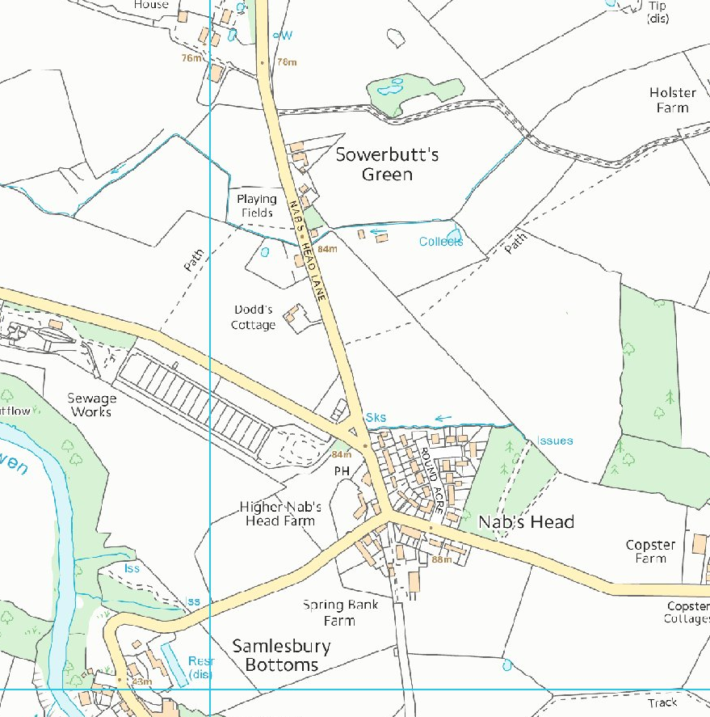
Existing play area and proposed location of new play equipment

Appendix B – Extract from Eastern My Neighbourhood Plan



